💰 Bank Loan Modelling — SQL Analytics Project Report
Author: Rohan Kumar Jha
Tools Used: MySQL Command Line Client, MySQL Workbench
Dataset: Bank Loan Modelling Dataset (UniversalBank)

🧭 1. Project Overview
This project analyzes customer demographic and financial data from a retail bank to understand which customers accepted a personal loan offer and what factors influence loan acceptance.
The goal of this project is to:
- Explore customer behavior
- Identify key drivers of loan acceptance
- Build SQL-based risk and marketing insights
- Perform segmentation and feature engineering
- Create a clean, professional analytics report
This project demonstrates:
- SQL data import
- Data validation
- Exploratory analysis
- Customer segmentation
- Risk and marketing analytics
- Clean, structured reporting

📦 2. Dataset Description
The dataset contains 5000+ customer records with demographic, financial, and behavioral attributes.
Column Definitions
Column Name | Description
ID | Unique customer ID
Age | Customer age (years)
Experience | Years of professional experience
Income | Annual income ($000)
ZIPCode | Customer ZIP code
Family | Family size
CCAvg | Avg. monthly credit card spending ($000)
Education | 1: Undergrad, 2: Graduate, 3: Professional
Mortgage | Mortgage value ($000)
Personal_Loan | 1 = accepted loan, 0 = rejected
Securities_Account | 1 = has securities account
CD_Account | 1 = has certificate of deposit
Online | 1 = uses internet banking
CreditCard | 1 = has bank-issued credit card
Why this dataset is valuable
- Realistic banking domain
- Perfect for credit risk & marketing analytics
- Clean, structured numerical data
- Ideal for SQL + data science workflows
- Allows segmentation, scoring, and pattern discovery

🧱 3. Database & Table Creation
Create database
CREATE DATABASE bank_loans;
USE bank_loans;
Create table
CREATE TABLE loan_data (
ID INT,
Age INT,
Experience INT,
Income INT,
ZIPCode INT,
Family INT,
CCAvg FLOAT,
Education INT,
Mortgage INT,
Personal_Loan INT,
Securities_Account INT,
CD_Account INT,
Online INT,
CreditCard INT
);

🖥️ 4. Importing the Dataset Using CMD
Move your CSV to:
C:\Users\itsro\OneDrive\Desktop\loan_data.csv
Import command
USE bank_loans;

LOAD DATA LOCAL INFILE 'C:\\Users\\itsro\\OneDrive\\Desktop\\loan_data.csv'
INTO TABLE loan_data
FIELDS TERMINATED BY ','
ENCLOSED BY '"'
LINES TERMINATED BY '\n'
IGNORE 1 ROWS;
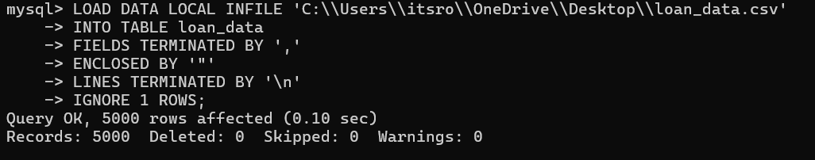

🔍 5. Data Validation in MySQL Workbench
Display first 5 rows
SELECT * FROM loan_data LIMIT 5;
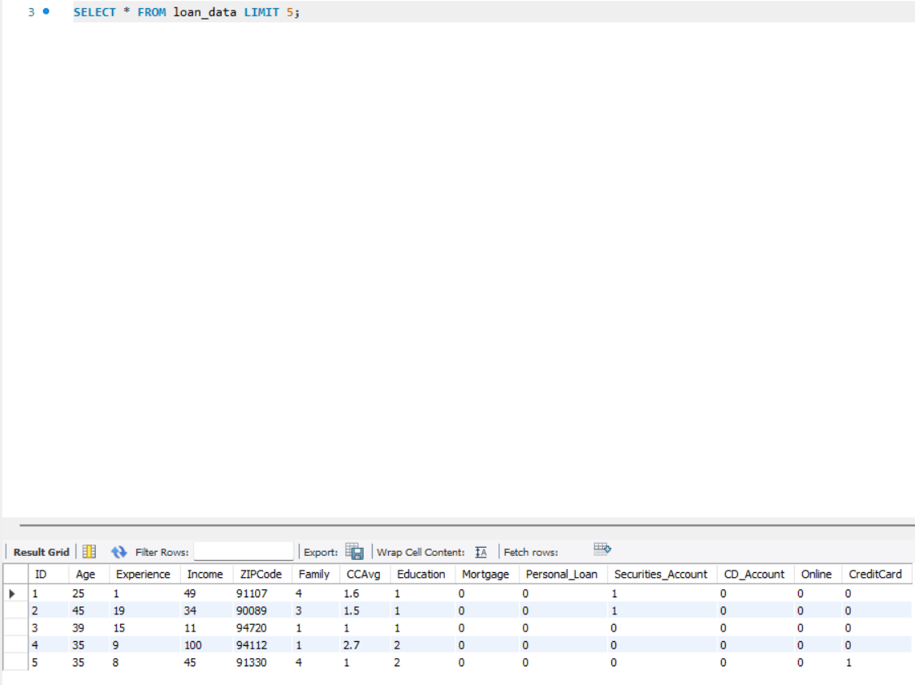
Count total rows
SELECT COUNT(*) FROM loan_data;
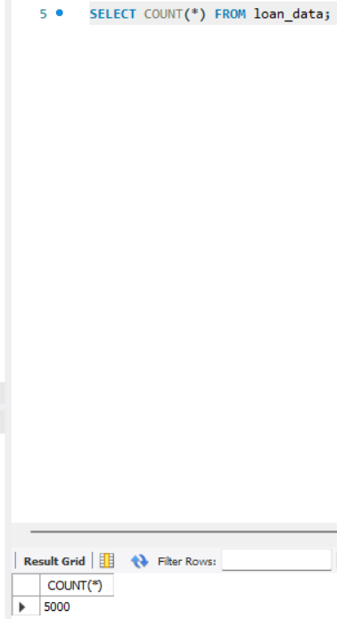
📘 6. Basic SQL Analysis (10 Tasks)

1. Loan acceptance count
SELECT Personal_Loan, COUNT(*) AS total
FROM loan_data
GROUP BY Personal_Loan;
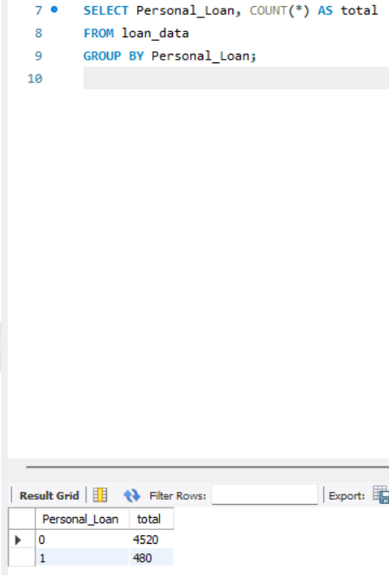
2. Average income of customers
SELECT AVG(Income) AS avg_income
FROM loan_data;
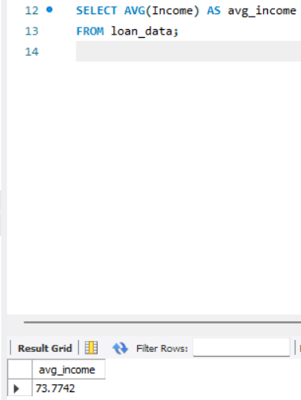
3. Count customers by education level (1: Undergrad, 2: Graduate, 3: Professional)
SELECT Education, COUNT(*) AS total
FROM loan_data
GROUP BY Education;
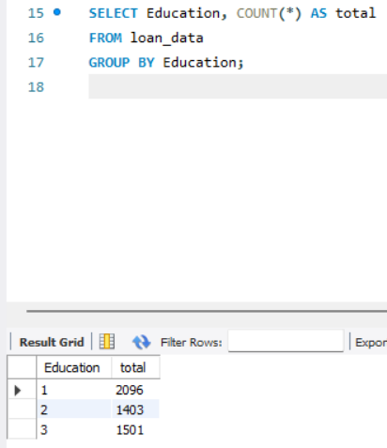
4. Average credit card spending
SELECT AVG(CCAvg) AS avg_spending
FROM loan_data;
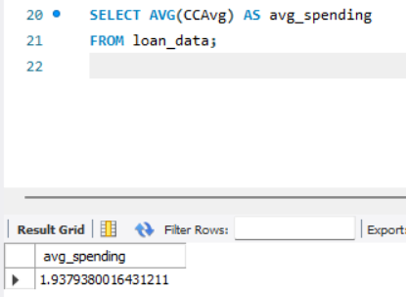
5. Customers with a mortgage
SELECT COUNT(*) AS mortgage_customers
FROM loan_data
WHERE Mortgage > 0;
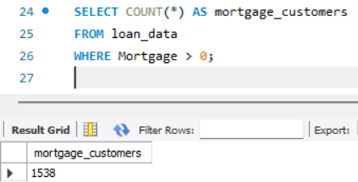
6. Loan acceptance by family size
SELECT Family, Personal_Loan, COUNT(*) AS total
FROM loan_data
GROUP BY Family, Personal_Loan;
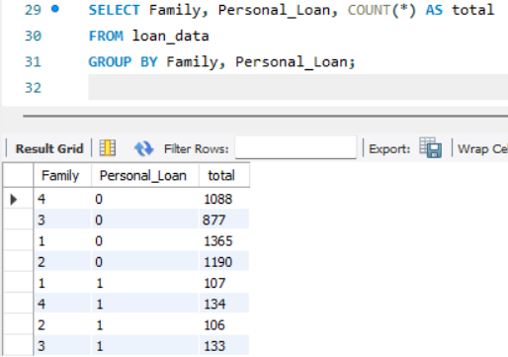

7. Customers using online banking
SELECT Online, COUNT(*) AS total
FROM loan_data
GROUP BY Online;
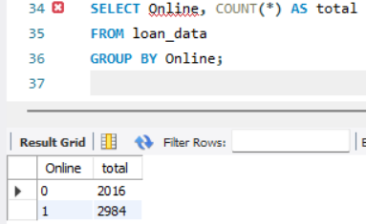
8. Customers with bank credit cards
SELECT CreditCard, COUNT(*) AS total
FROM loan_data
GROUP BY CreditCard;
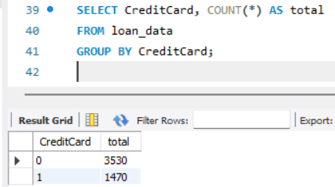

9. Highest income customers
SELECT ID, Income
FROM loan_data
ORDER BY Income DESC
LIMIT 10;
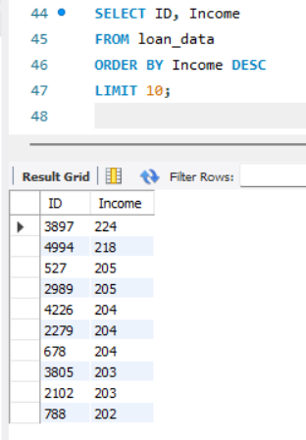

10. Customers with high credit card spending
SELECT ID, CCAvg
FROM loan_data
WHERE CCAvg > 3;
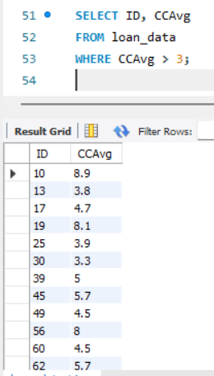

🔥 7. Advanced SQL Analysis (15 Tasks)

1. Income-to-spending ratio
SELECT ID, Income, CCAvg,
Income / NULLIF(CCAvg, 0) AS income_spending_ratio
FROM loan_data;
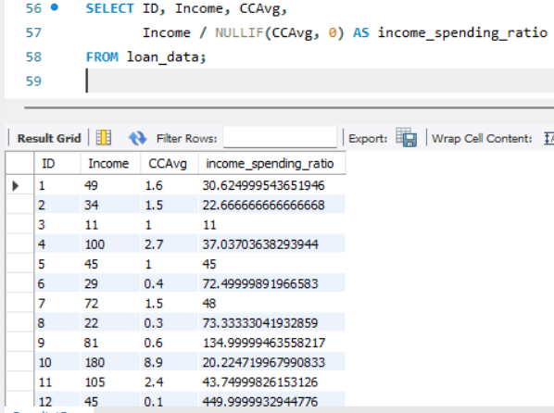

2. Loan acceptance by income group
SELECT
CASE
WHEN Income < 50 THEN 'Low Income'
WHEN Income BETWEEN 50 AND 100 THEN 'Middle Income'
ELSE 'High Income'
END AS income_group,
Personal_Loan,
COUNT(*) AS total
FROM loan_data
GROUP BY income_group, Personal_Loan;
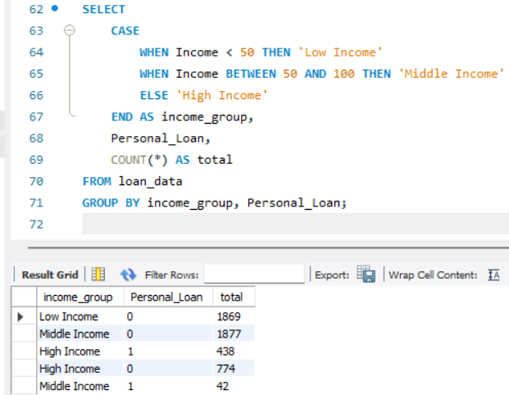

3. Loan acceptance by education
SELECT Education, Personal_Loan, COUNT(*) AS total
FROM loan_data
GROUP BY Education, Personal_Loan;
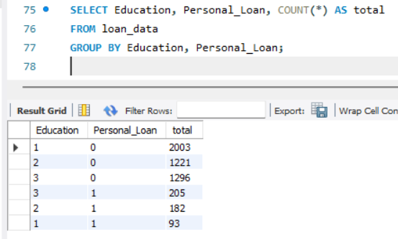
4. Customers with high income but no loan
SELECT *
FROM loan_data
WHERE Income > 100 AND Personal_Loan = 0;
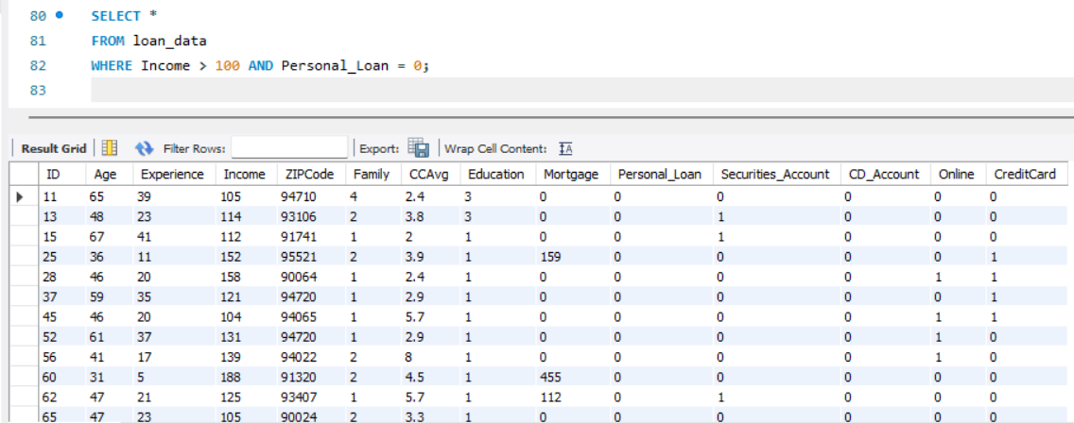

5. Customers with low income but accepted loan
SELECT *
FROM loan_data
WHERE Income < 40 AND Personal_Loan = 1;
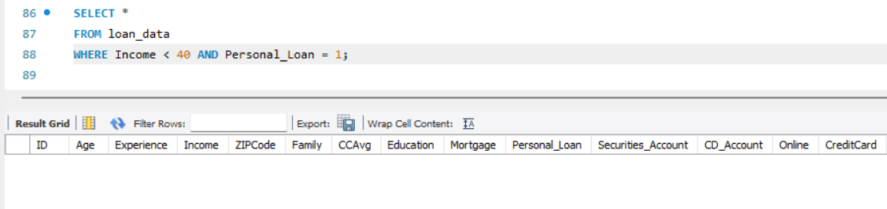
6. Loan acceptance by credit card usage
SELECT CreditCard, Personal_Loan, COUNT(*) AS total
FROM loan_data
GROUP BY CreditCard, Personal_Loan;
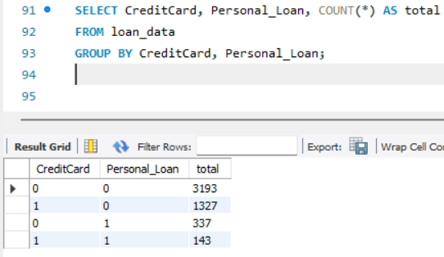

7. Loan acceptance by online banking usage
SELECT Online, Personal_Loan, COUNT(*) AS total
FROM loan_data
GROUP BY Online, Personal_Loan;
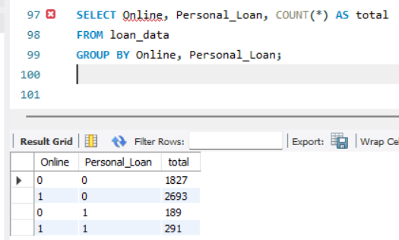
8. Loan acceptance by securities account
SELECT Securities_Account, Personal_Loan, COUNT(*) AS total
FROM loan_data
GROUP BY Securities_Account, Personal_Loan;
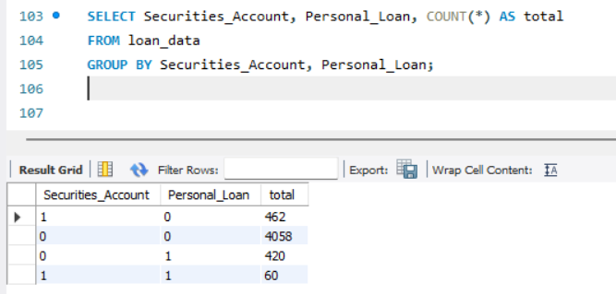
9. Loan acceptance by CD account
SELECT CD_Account, Personal_Loan, COUNT(*) AS total
FROM loan_data
GROUP BY CD_Account, Personal_Loan;
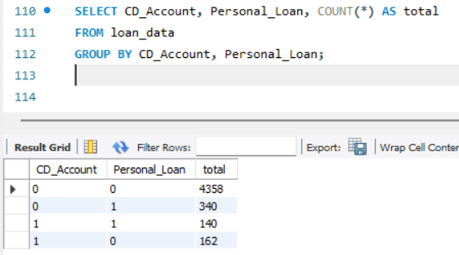
10. Mortgage vs loan acceptance
SELECT
CASE WHEN Mortgage > 0 THEN 'Has Mortgage' ELSE 'No Mortgage' END AS mortgage_status,
Personal_Loan,
COUNT(*) AS total
FROM loan_data
GROUP BY mortgage_status, Personal_Loan;
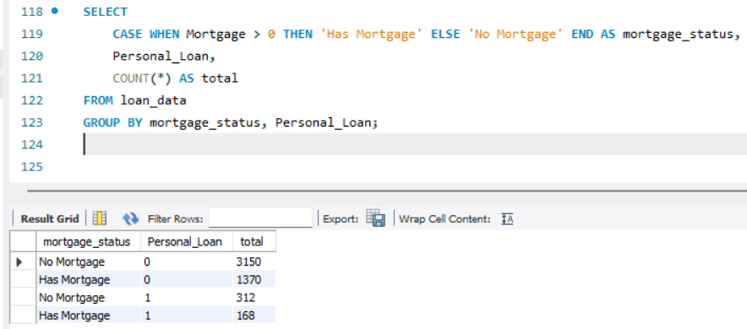
11. High-risk customers (low income + high spending)
SELECT *
FROM loan_data
WHERE Income < 40 AND CCAvg > 3;
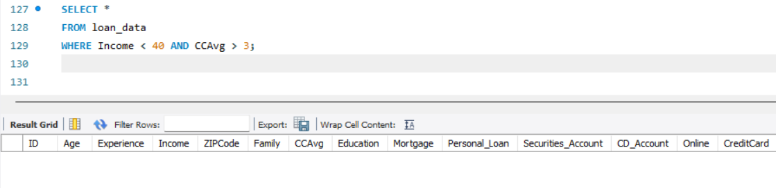
12. Build a “Marketing Score”
SELECT ID,
ROUND(Income * 0.4 +
CCAvg * 0.3 +
Online * 10 +
CreditCard * 10, 2) AS marketing_score
FROM loan_data
ORDER BY marketing_score DESC;
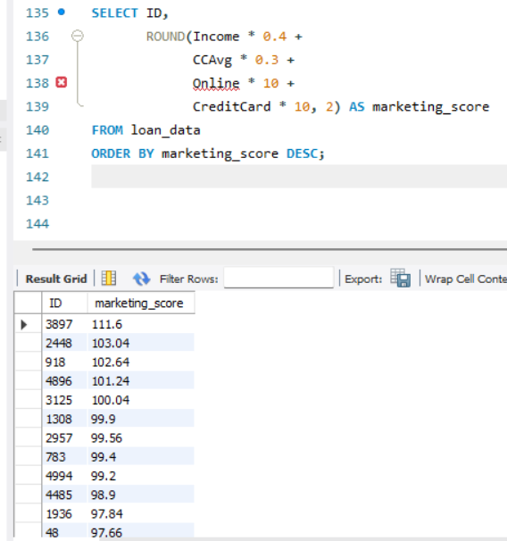
13. Build a “Risk Score”
SELECT ID,
ROUND(Income * 0.3 +
Mortgage * 0.2 -
CCAvg * 0.5 -
CD_Account * 20, 2) AS risk_score
FROM loan_data
ORDER BY risk_score ASC;
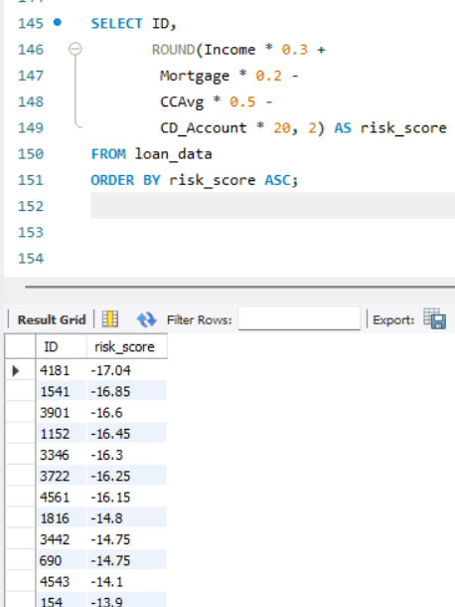

14. Customers likely to accept future loans (SQL heuristic)
SELECT *
FROM loan_data
WHERE Income > 60
AND CCAvg > 2
AND Online = 1
AND CreditCard = 1;
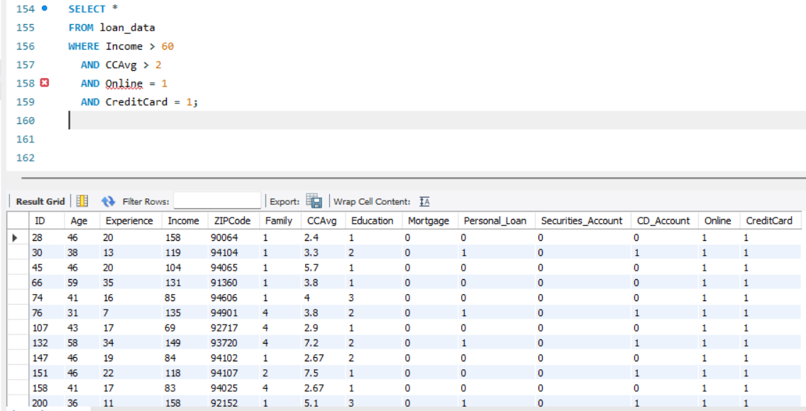

15. Identify the top ZIP codes with the highest loan acceptance rate
SELECT
ZIPCode,
SUM(Personal_Loan) AS loans_accepted,
COUNT(*) AS total_customers,
ROUND(SUM(Personal_Loan) / COUNT(*) * 100, 2) AS acceptance_rate
FROM loan_data
GROUP BY ZIPCode
HAVING COUNT(*) > 20
ORDER BY acceptance_rate DESC
LIMIT 10;
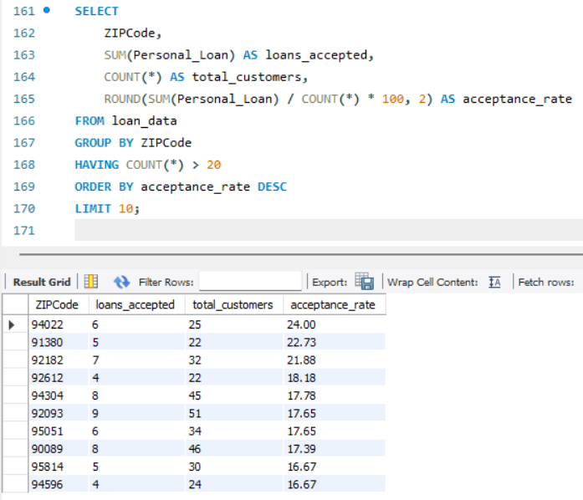

🏁 8. Conclusion
This Bank Loan Modelling SQL project provides a complete analysis of customer behavior and loan acceptance patterns.
Through this project, we explored:
- Customer demographics
- Income and spending behavior
- Loan acceptance trends
- Risk and marketing insights
- Segmentation and scoring
- Feature engineering for predictive modelling
This project demonstrates strong SQL capabilities, including:
- Data import
- Data validation
- Aggregations and grouping
- Conditional logic
- Scoring models
- Analytical storytelling

